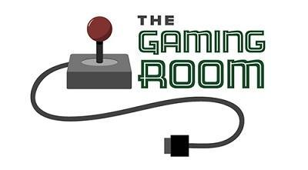

<Name-of-Software-Application>

CS 230 Project Software Design Template
Version 1.0

Table of Contents

CS 230 Project Software Design Template 1
Table of Contents 2
Document Revision History 2
Executive Summary 3
Requirements 3
Design Constraints 3
System Architecture View 3
Domain Model 3
Evaluation 4
Recommendations 5

Document Revision History

Version | Date | Author | Comments
1.0 | 09/23/26 | Seth Agbabiaka | <Brief description of changes in this revision>

Instructions
Fill in all bracketed information on page one (the cover page), in the Document Revision History table, and below each header. Under each header, remove the bracketed prompt and write your own paragraph response covering the indicated information.

Executive Summary

The client wants an application that is similar to Win, Lose, or Draw where the app displays an image from a library of drawings. The game will have 4 one minute rounds and for each round, the drawing will gradually be revealed at 30 seconds. If a team can’t solve the puzzle before the end of the round, the other teams can provide one guess within 15 seconds. The client needs an OOP software that will organize the game, teams, and players. They will all have unique identifiers so the application is able to keep track of the individual objects.

Requirements

- Game must be able to have multiple teams
- Each team must be able to have players assigned
- All games, teams, and players must have unique identifiers
- Each round must have one minute time limits
- App must be able to function on multiple devices and platforms
- Drawings must be able to be rendered
- OOP and design patterns should be used

Design Constraints

The application should be able to have multiple teams with multiple players on each team. The software has to have an object structure to allow this without creating objects that conflict each other
The names of each game and team can’t be duplicated so users have to be able to know if a name is already being used. The app should be able to check objects that already exist before allowing a new game or team to be created.
The app has time sensitive events with each game being 4 one minute rounds and at 30 seconds the drawing is gradually revealed. The app has to be able to recognize when the timer reaches 30 seconds for the drawing to be revealed and one minute for the round to end.
The app is web based so the design should be compatible for users. The software has to support the current requirements as well as allowing for future updates.

System Architecture View

Please note: There is nothing required here for these projects, but this section serves as a reminder that describing the system and subsystem architecture present in the application, including physical components or tiers, may be required for other projects. A logical topology of the communication and storage aspects is also necessary to understand the overall architecture and should be provided.

Domain Model

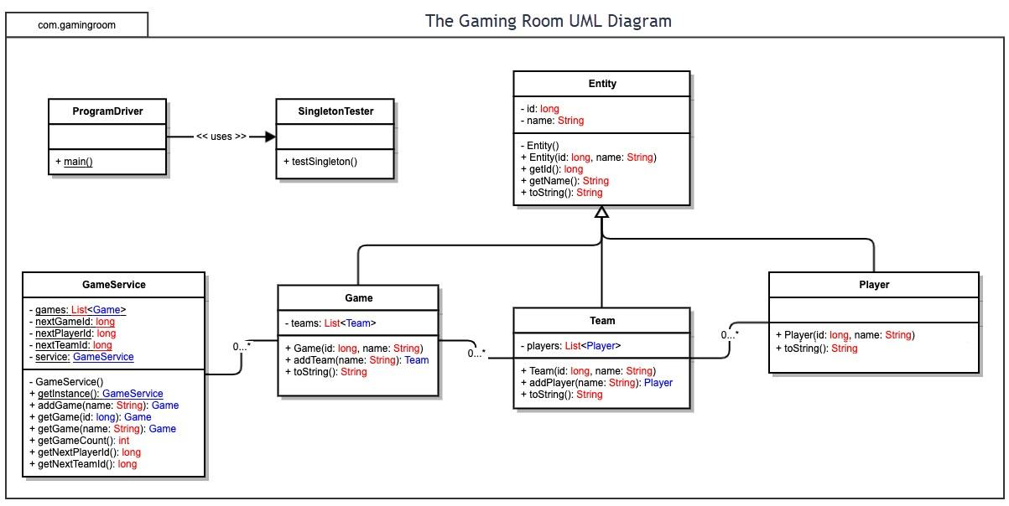

Evaluation

Using your experience to evaluate the characteristics, advantages, and weaknesses of each operating platform (Linux, Mac, and Windows) as well as mobile devices, consider the requirements outlined below and articulate your findings for each. As you complete the table, keep in mind your client’s requirements and look at the situation holistically, as it all has to work together.

In each cell, remove the bracketed prompt and write your own paragraph response covering the indicated information.

Development Requirements | Mac | Linux | Windows | Mobile Devices
Server Side | macOS can support web servers and tools. It gives a stable environment that works with programming languages. Mac is usually more expensive and isn’t used for web servers as much. | Linux is stable and secure. It is commonly used for hosting web servers. It is open source as well which reduces cost. | Windows can host web applications. Heavily supports databases and microsoft features. It has a lot of good administrative tools. | Not a good choice for a main server. Has limited processing power, battery life, and storage.
Client Side | Web applications can be accessed through browsers such as chrome or safari. Takes a good level of time and experience | Can be accessed through firefox or chrome. Requires more technical skill to manage. | Windows supports Chrome, Edge, and Firefox. Due to licensing, costs can be on the higher side. | Will need to use touch controls instead of mouse and keyboard. Will need responsive web design to adapt to various screen sizes. Will need more time for developing and testing.
Development Tools | Developers can use Java, Eclipse, or Visual Studios. macOS also offers tools like Git and Java development tools. | Supports Java, Eclipse, Notepad++, and Visual Studio Code. Developers can use in-line tools and web servers. | Supports Java, Eclipse, Notepad++, and Visual Studio Code. MySQL is also available. | Can use HTML, CSS, and JavaScript. Android Studio would be used for Androids and Xcode for iOS.

Recommendations

Analyze the characteristics of and techniques specific to various systems architectures and make a recommendation to The Gaming Room. Specifically, address the following:

- Operating Platform: I think Windows Server would be a great choice as the operating platforming. Windows Server can support Java, web servers, and development tools that will be used for the application. It’s flexible and can accommodate future updates to The Gaming Room. Users can access Draw It or Lose It through Mac, Linux, Windows, and mobile devices.

- Operating Systems Architectures: Windows Server allows the operating system to provide services to other layers through the core. The core manages important resources and hardware. Applications run above the system instead of directly controlling the hardwares.
- Storage Management: The Windows Server uses storage devices such as disks and tapes. Disk storage can be used for active data such as the teams and players, as well as other account information. The stock drawing library would also be on disk storage. Since it’s faster to access information on disks, it would be beneficial to store data like that there since the game is constantly accessing and changing information. Tapes would be used for backup storage. If there is any type of outage, important data can be backed up on a tape so that it can be restored.

- Memory Management: Windows Server employs strategies that manage the computer’s memory and provides applications with their needed memory. Windows moves information that isn’t used as often from physical memory to disk storage when needed. Multiple processes can run while sharing the same resources.

- Distributed Systems and Networks: The main application can still run on a Windows Server, and other users can connect through another client. Since the application is web-based, the other clients don’t need to run on Windows. The app can use HTTPS and other web protocols to connect the clients and the server. The client relies on a network connection so it can connect to the server. If the internet connection is unavailable or the servers and databases go down, the users will not be able to access the game.

- Security: Windows Server offers various security measures to protect data. There's user passwords to protect accounts and multi-factor authentication options. There are also security features like Firewall and access controls. Windows Server provides backup options and monitoring.

